Monthly Nutrition News

*Extra! Extra!* Read all about what’s breaking news in nutrition every month through the Food Bank of Delaware **website (www.fbd.org)** and **Facebook page**! #FBDmonthlynutritionnews

|  |  |
| --- | --- |
| **2018 Monthly Nutrition Events** | |
| **July** | Food access over the summer and in season foods |
| **August** | National Breastfeeding Month |
| **September** | Fruits &Vegetable-More Matters Month & Family Health and Fitness Day |
| **October** | Health Literacy Month |
| **November** | American Diabetes Month |
| **December** | National Handwashing Awareness Week |
| **January** | Folic Acid Awareness Week |
| **February** | American Heart Month |
| **March** | National Nutrition Month |
| **April** | National Public Health Week & World Health Day |
| **May** | Food Allergy Action Month & National Women’s Health Week |
| **June** | Men’s Health Month & Week |

***Questions?* Contact:**

**Taylor Massey** BS, BA

*WIC Outreach Nutritionist*

Newark Branch

14 Garfield Way

Newark, DE 19713

*Phone*: (302)292-1305

*Fax*: (302)292-1309

*Email*: [tmassey@fbd.org](mailto:tmassey@fbd.org)

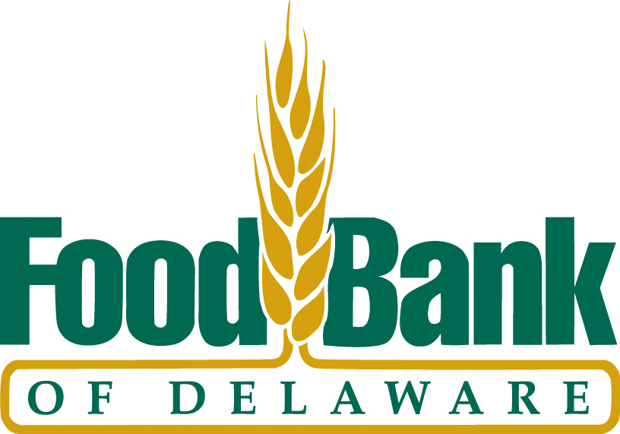

Monthly Nutrition News

Extra! Extra! Read all about what’s breaking news in nutrition every month through the Food Bank of Delaware **website (www.fbd.org)** and **Facebook page**! #FBDmonthlynutritionnews

|  |  |
| --- | --- |
| **2018 Monthly Nutrition Events** | |
| **July** | Food access over the summer and in season foods |
| **August** | National Breastfeeding Month |
| **September** | Fruits &Vegetable-More Matters Month & Family Health and Fitness Day |
| **October** | Health Literacy Month |
| **November** | American Diabetes Month |
| **December** | National Handwashing Awareness Week |
| **January** | Folic Acid Awareness Week |
| **February** | American Heart Month |
| **March** | National Nutrition Month |
| **April** | National Public Health Week & World Health Day |
| **May** | Food Allergy Action Month & National Women’s Health Week |
| **June** | Men’s Health Month & Week |

***Questions?* Contact:**

**Taylor Massey** BS, BA

*WIC Outreach Nutritionist*

Newark Branch

14 Garfield Way

Newark, DE 19713

*Phone*: (302)292-1305

*Fax*: (302)292-1309

*Email*: [tmassey@fbd.org](mailto:tmassey@fbd.org)

